Originator:
Name | Job Title | Signature | Date
Brian Cullinan | Software Developer
Approvals:
Name | Job Title | Signature | Date
Scott Pletzer | Director of Quality & Program Management
Andrew Mason | Chief Technology Officer

Revision History
Revision | Revision Date | Reason for Revision/Change Request | Revised By
000 | 18May12 | Initial Release | S. Pletzer

- Purpose
The purpose of this document is to describe how the EPIC Shell was implemented.
- Scope

- Definitions
Shell | Software used to access features of the operating system (Windows XP) such as viewing tasks (e.g. ClearView) and running and closing applications.
Windows Registry | A place to store application settings for Windows and software that runs on Windows.
Windows API | A set of functions provided by windows that control the interactions between software and the Windows desktop manager.

- Specification
  - The EPIC Shell uses Windows API calls that are completed compatible with Windows XP and Windows 7.
  - The default Windows logon mechanism is used to access the shell, when the username and password is entered, the Shell is opened after the user logs in:
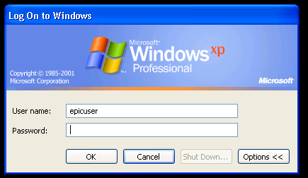
  - The shell can be configured for individual logins by following the instructions in Attachment A.
  - The shell starts for a particular user automatically by setting Shell in the Windows Registry.
Key | HKCU\ Software\Microsoft\Windows NT\CurrentVersion\Winlogon
Name | Shell
Value | C:\Windows\Shell.exe (our application)
Type | String (REG_SZ)
  - The shell launches as a task bar application that fits the width of the screen. It configures windows to fill the screen size minus the size of the taskbar when not in Auto-hide mode.
The Windows API call used to adjust the working area of the screen is called SystemParametersInfo, SPI_SETWORKAREA. More documentation can be found by searching Microsoft for that function call.
The shell also attaches to the SystemEvents.DisplaySettingsChanged event to ensure it maintains the full width of the screen.
  - There are no options to close out of the shell; it only displaces a taskbar and the Windows background.
  - The Task Manager is disabled using a registry key:
Key | HKCU\ Software\Microsoft\Windows\CurrentVersion\Policies\System
Name | DisableTaskMgr
Value | 0 to allow access, 1 to disable access
Type | 32 bit value (REG_DWORD)
  - The only options for the shell are to launch ClearView, Log-off, shutdown, or edit the settings. It cannot be closed otherwise. Exit is only down to administrator accounts.
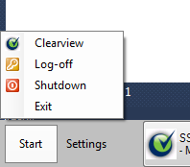
System keys are captured by the shell and some are ignored. This is done using a low level Windows event hook. This is done by calling SetWindowsHookEx with a hook type of KEYBOARD_LL. More information can be found by searching the Windows API for that call.
Alt+Tab, Alt+F4, Alt+ESC, CTRL+Shift+ESC are all captured and cancelled. The Windows key will bring up the Start menu just like in the default shell. Pressing CTRL+ALT+DEL will display the Settings menu for changing the shell settings.
  - The start button in the lower left corner is shown above.
  - The taskbar can be optionally hidden by right clicking the taskbar and checking the Auto-hide option:
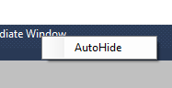
  - The time is extracted from Windows and will reflect whatever cultural settings are set by the administrator.
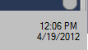
  - As shown in 4.9, Exit is only displayed to administrators for convenience. Log-off and shutdown can be used. ClearView opens the program specified in the Settings dialog.
  - In the settings dialog, “Set desktop background” can be checked, this calls the Windows API function SystemParametersInfo with the option SPI_SETDESKWALLPAPER. It also sets the desktop background in the registry and directs the Wallpaper setting to %UserProfile%\clearview.bmp.
Key | Software\Microsoft\Windows\CurrentVersion\Policies\System
Name | Wallpaper
Value | C:\Document and Settings\epicuser\clearview.bmp
Type | String (REG_SZ)
  - Access to printer configuration can be done by logging in as EPICAdministrator where the shell is not present.
  - Access to network configuration can be done by logging in as EPICAdministrator where the shell is not present.
- Reference
N/A
- Attachments
N/A

